**WEBPORTAL FOR college CHATBOT**

**ABSTRACT**

In recent years, the integration of chatbot technology in various domains has seen a significant rise, facilitating streamlined interactions and services. This paper presents the development and implementation of a college chatbot, an intelligent conversational agent tailored to meet the diverse needs of college students, faculty, and staff. The college chatbot aims to enhance the efficiency of information dissemination, provide timely assistance.

And offer personalized guidance across a range of academic and administrative tasks. Leveraging natural language processing (NLP) and machine learning techniques, the chatbot is designed to understand user queries, provide relevant responses, and adapt to user preferences over time. Key functionalities include course information retrieval, campus event notifications, academic advising, administrative assistance.

And integration with existing college systems. The chatbot's interface is designed to be user-friendly, accessible through various platforms including web browsers, mobile applications, and messaging platforms. Additionally, the chatbot incorporates mechanisms for continuous learning and improvement through user feedback and data analytics.

Through the development and deployment of the college chatbot, this project aims to enhance the overall user experience within the college ecosystem, fostering improved communication, efficiency, and engagement among students, faculty, and staff. In the contemporary educational landscape, colleges and universities are witnessing an increasing demand for efficient and personalized communication channels to cater to the needs of prospective students, current students, faculty, and staff. To address this demand, the development of a College Enquiry Chatbot (CEC) emerges as a promising solution.

The CEC serves as an AI-powered conversational interface that interacts with users in natural language, providing information and assistance related to various aspects of college life.In the contemporary educational landscape, colleges and universities are witnessing an increasing demand for efficient and personalized communication channels to cater to the needs of prospective students, current students, faculty, and staff. To address this demand, the development of a College Enquiry Chatbot (CEC) emerges as a promising solution. The CEC serves as an AI-powered conversational interface that interacts with users in natural language, providing information and assistance related to various aspects of college life.

**CHAPTER 1**

**PROJECT DESCRIPTION**

* 1. **INTRODUCTION**

In today's fast-paced world, educational institutions face numerous challenges in managing inquiries from prospective students efficiently and effectively. With advancements in technology and the growing demand for personalized experiences, traditional methods of handling college inquiries are becoming outdated. This has led to the emergence of college enquiry chatbots as a transformative solution.

In the digital age, technological advancements continue to reshape the landscape of higher education, offering innovative solutions to meet the evolving needs of college communities. One such innovation is the emergence of chatbot technology, heralding a new era of efficient and personalized communication within academic institutions. With the proliferation of online platforms and the increasing demand for instant access to information, the development of a college chatbot represents.

A pivotal step towards enhancing the student experience, optimizing administrative processes, and fostering a more connected campus environment. This introduction sets the stage for exploring the development, implementation, and potential impact of a college chatbot, elucidating its role as a versatile tool poised to revolutionize communication and support services across various facets of college life.

This paper presents the design and implementation of a CEC tailored to the specific needs of a college or university environment. The CEC is built upon state-of-the-art natural language processing (NLP) and machine learning techniques, enabling it to understand user queries, extract relevant information, and generate appropriate responses. The system is trained using a diverse dataset comprising frequently asked questions, campus policies, academic programs, admission criteria, and other relevant information.

As the number of students seeking admission to colleges and universities continues to rise, educational institutions are tasked with managing a large volume of inquiries. Traditional methods of handling inquiries, such as phone calls and emails, are often time-consuming and can lead to delays in response times. Additionally, human agents may not always be available to respond to inquiries promptly, especially during peak periods.

Here are some key features and benefits of our college chatbot:

College enquiry chatbots offer a solution to these challenges by providing instant, round-the-clock support to prospective students. These AI-powered chatbots can engage with multiple users simultaneously, providing accurate and personalized responses to their queries. By automating the inquiry handling process, colleges can improve efficiency, reduce response times, and enhance the overall experience for prospective students.

College enquiry chatbots leverage natural language processing (NLP) and machine learning algorithms to understand and respond to user inquiries in real-time. When a prospective student interacts with the chatbot through a website or messaging platform, the chatbot analyses the user's message and identifies the intent behind it. Based on this intent, the chatbot retrieves relevant information from a knowledge base and formulates a response.

These chatbots are trained on large datasets of past inquiries and responses, allowing them to learn and improve over time. They can handle a wide range of inquiries, including questions about admissions criteria, program offerings, campus facilities, and financial aid options. Additionally, chatbots can provide personalized recommendations based on the user's preferences and interests, helping students find the information they need quickly and easily.

Implementing college enquiry chatbots offers several benefits to educational institutions and prospective students alike. For colleges and universities, chatbots streamline the inquiry handling process, freeing up human resources to focus on more complex tasks. They can also provide valuable insights into user behavior and preferences, allowing institutions to optimize their recruitment strategies.

For prospective students, chatbots offer convenience and accessibility, allowing them to get instant answers to their questions without having to wait for a response. Chatbots can also personalize the inquiry experience, providing tailored information based on the user's background and interests. Ultimately, college enquiry chatbots play a crucial role in enhancing the overall admissions experience and helping students make informed decisions about their educational future.

A college bot project is built using artificial algorithms that analyzes user’s queries and understand user’s message. This application is developed for android devices. The system recognizes user’s query and understands what he wants to convey and simultaneously answers them appropriately. The questions asked by the users can be in any format. There is no specific format for users to ask questions. The built in artificial intelligence system realizes users requirements and provides suitable answers to the user. It also uses a graphical representation of a person speaking while giving answers as a real person would do.

College Chatbot using NLP and Machine Learning is a project aimed at developing a chatbot system for college that can assist users with their inquiries. This system will utilize Natural Language Processing (NLP) and Machine Learning (ML) algorithms to provide an intelligent and personalized customer experience. Developing a chatbot system that meets these requirements presents several challenges. The system must be able to accurately understand and interpret inquiries, which can vary in complexity and language.

The system must also be able to handle a high volume of user inquiries simultaneously, ensuring that wait times are minimized. Here we create a customer front-end application which further enhances the customer experience. This hypothesis is supported by previously published literature that highlights the potential benefits of chatbot systems in enhancing user service in various industries, including banking. To reduce the burden on human customer service representatives and provide customers with immediate assistance at any time.

The base paper of this project is a literature survey of previously published works that have explored the use of chatbot systems in customer service. The base paper highlights the potential benefits of using NLP and ML algorithms in developing chatbot systems that can handle complex customer inquiries and provide accurate responses in natural language.

Among these advancements, chatbots have emerged as a powerful tool for enhancing the student experience and streamlining administrative processes in educational institutions. College enquiry chatbots, in particular, play a pivotal role in revolutionizing student support services by providing instant assistance, personalized guidance, and efficient information retrieval.

**24/7 availability:** Our chatbot is available round-the-clock, allowing you to access college support whenever you need them, even outside regular college days.

**User-friendly interface:** Our chatbot is designed with simplicity in mind. You don't need to be a tech expert to use it. The intuitive interface makes accessible to everyone.

**Continuous improvement:** We're committed to enhancing the capabilities of our chatbot continuously. As technology evolves, we strive to update and refine our chatbot to deliver an even better experience.

**Course Information**: Provide details about various courses offered by the college, including curriculum, duration, eligibility criteria, and any prerequisites.

**Admissions Information**: Assist users in understanding the admissions process, deadlines, required documents, and admission criteria for different programs.

**Campus Facilities**: Offer information about campus facilities such as libraries, laboratories, sports facilities, student accommodation, dining options, and recreational areas.

**Faculty Information**: Provide details about faculty members, their qualifications, areas of expertise, research interests, and contact information.

**Events and Activities**: Inform users about upcoming events, workshops, seminars, cultural programs, and extracurricular activities happening on campus.

These are some of the key features that a college enquiry chatbot can include to provide comprehensive assistance to users seeking information about the college. the specific features can be customized based on the college's requirements, target audience, and priorities.

Top of Form

Whether you're looking to check some information about the college, library, or latest college events, our chatbot is here to assist you every step of the way. Experience the future of college today with our intelligent and efficient college chatbot. Get started now and unlock a world of convenience at your fingertips.

Top of Form

**1.2 EXISTING SYSTEM**

In the earlier days students had to visit the college to enquire about details like courses,fee structure ,admission process and other information's about the college ,which is a tiresome process as well as long process for both parents as well as students. Now a days there are many changes occurred in the Education system with help of advanced technology. Everything is happening over the internet without any trouble. In those days for enquiring about courses we have to visit the college, but as the days are passing away its completing changing. Collecting the course details, fee structure manually will be hectic procedure and it also needs a manpower. For reducing that manpower and avoid such difficulties and time consuming many devices or systems were emerged day by day.

**DISADVANTAGES**

The existing systems in colleges often rely on traditional methods of communication and support, which may be limited by factors such as business hours and human resource availability.

This can lead to delays in accessing information and support services, impacting the overall efficiency and user experience.

**Time-consuming**: traditional office visitation systems often involve manual processes, such as filling out paperwork upon arrival or waiting in line to check in with a receptionist. This can be time-consuming for both visitors and staff.

**Resource intensive**: manually managing office visitation requires dedicated staff to handle paperwork, greet visitors, and manage visitor logs. This can be resource-intensive and may result in increased operational costs.

**Security risks**: paper-based visitor logs can be prone to errors and tampering, potentially compromising security. Additionally, without proper verification processes, unauthorized individuals may gain access to sensitive areas.

**Limited accessibility**: visitors may face challenges in accessing the office during non-standard hours or if there are physical barriers such as long distances to travel or mobility issues.

**1.3 PROPOSED SYSTEM**

The proposed college chatbot system is designed to revolutionize the way students, faculty, and staff interact with college services and support. It offers a comprehensive solution to address the limitations of the existing system by providing round-the-clock access and personalized assistance through a conversational interface Users can access college services and support anytime, anywhere, eliminating the constraints of regular business hours. The chatbot employs advanced NLP techniques to understand user queries in natural language, allowing for seamless and intuitive interactions. The chatbot seamlessly integrates with existing college systems such as student information systems, learning management systems, and event calendars, enabling access to up-to-date information and services.

**Advantages**

The proposed college chatbot aims to address the limitations of the existing system by providing 24/7 access to college services and support through a conversational interface.

By leveraging natural language processing and machine learning technologies, the chatbot will be able to understand user queries, provide relevant information, and offer personalized assistance.

**Scalability**: Chatbots can handle multiple conversations simultaneously, scaling to accommodate a large volume of inquiries without the need for additional resources. This scalability enables businesses to efficiently manage customer interactions, even during peak periods, without experiencing delays or disruptions.

**Cost-Effectiveness:** Chatbots can automate repetitive tasks and inquiries, reducing the need for human intervention and minimizing operational costs. By handling routine inquiries and support requests, chatbots free up human agents to focus on more complex or high-value tasks, maximizing efficiency and productivity**.**

**Consistent Responses:** Chatbots provide consistent and standardized responses to customer inquiries, ensuring that every interaction delivers accurate information and maintains brand consistency. This consistency helps build trust and credibility with customers, enhancing the overall customer experience**.**

**Instantaneous Response Time:** Chatbots provide immediate responses to customer inquiries, eliminating the need for customers to wait in queues or navigate through complex phone menus. This instantaneous response time improves customer satisfaction and reduces frustration, leading to higher engagement and retention rates**.**

**Personalization:** Advanced chatbots leverage machine learning and natural language processing (NLP) to personalize interactions based on user preferences, behavior, and history. By analyzing user data and context, chatbots can tailor responses and recommendations to meet individual needs, enhancing the relevance and effectiveness of interactions**.**

**Data Collection and Analysis:** Chatbots capture valuable data from customer interactions, including preferences, feedback, and purchase history. This data can be used to gain insights into customer behavior, identify trends, and inform business decisions. Additionally, chatbots can integrate with customer relationship management (CRM) systems to centralize and manage customer data effectively**.**

**Multichannel Integration:** Chatbots can be deployed across various channels, including websites, mobile apps, social media platforms, and messaging apps. This multichannel integration enables businesses to reach customers wherever they are and provide consistent support and engagement across different touchpoints.

**Lead Generation and Sales:** Chatbots can engage with users proactively, guiding them through the sales funnel, and assisting with product recommendations, purchases, and inquiries. By providing personalized assistance and facilitating transactions, chatbots contribute to lead generation, conversion, and revenue growth.

Overall, chatbots offer numerous advantages for businesses, including improved customer service, increased efficiency, cost savings, and enhanced user engagement. By leveraging chatbot technology effectively, businesses can streamline operations, drive customer satisfaction, and gain a competitive edge in today's digital landscape.

**chapter 2**

**PROBLEM SURVAY**

**2.1 MACHINE LEARNING**

Machine learning (ml) is a subfield of artificial intelligence (ai) that focuses on the development of algorithms and models capable of learning from data to make predictions or decisions without explicit programming. At its core, ml involves the construction of statistical models that can learn patterns and relationships from large datasets and then generalize this knowledge to new, unseen data. This ability to learn and adapt from experience distinguishes machine learning from traditional rule-based programming paradigms, making it well-suited for complex tasks where explicit programming would be impractical or infeasible.

ML algorithms can be broadly categorized into three main types: supervised learning, unsupervised learning, and reinforcement learning. In supervised learning, algorithms are trained on labelled data, where each example is associated with a target output. The goal is to learn a mapping from inputs to outputs, enabling the model to predict the correct output for new inputs. Unsupervised learning, on the other hand, involves training algorithms on unlabelled data to discover hidden patterns or structures within the data.

This can include tasks such as clustering, dimensionality reduction, and anomaly detection. Reinforcement learning is a type of learning where an agent learns to interact with an environment by taking actions and receiving feedback in the form of rewards or penalties. Over time, the agent learns to maximize its cumulative reward by choosing actions that lead to desirable outcomes.

Ml techniques have found widespread application across various domains, including computer vision, natural language processing, healthcare, finance, and robotics, among others. In computer vision, ml algorithms are used to analyze and interpret visual data, enabling tasks such as object detection, image classification, and facial recognition. In natural language processing, ml models process and understand human language, facilitating tasks such as language translation, sentiment analysis, and chatbot interaction.

In healthcare, ml algorithms assist in disease diagnosis, drug discovery, and personalized treatment planning by analysing patient data and medical images. Across these and many other domains, machine learning continues to drive innovation and transform industries, unlocking new opportunities for automation, optimization, and insight generation.

Machine learning (ml) has been applied to a wide range of problems across various domains. Here are some examples of problems that have been successfully addressed using machine learning techniques:

**Image Recognition:**

ML algorithms have been used to develop image recognition systems capable of identifying objects, people, scenes, and patterns within images. Applications include facial recognition, object detection, medical image analysis, and autonomous vehicles.

**Natural Language Processing (NLP):**

ML models have significantly advanced NLP tasks such as language translation, sentiment analysis, text summarization, and named entity recognition. Chatbots and virtual assistants also heavily rely on NLP techniques.

**Recommendation Systems:**

ML-powered recommendation systems analyze user preferences and behavior to provide personalized recommendations for products, movies, music, articles, and other content. These systems enhance user experience and increase engagement on platforms like e-commerce websites and streaming services.

**Predictive Analytics:**

ML algorithms are used for predictive analytics in various fields such as finance, healthcare, marketing, and supply chain management. They can forecast future trends, identify potential risks, detect anomalies, and optimize decision-making processes.

**Healthcare Diagnostics:**

ML models are applied to medical data for disease diagnosis, prognosis, and treatment recommendation. They analyze patient data including medical images, genomic data, electronic health records (EHRS), and wearable device data to assist healthcare professionals in making accurate diagnoses and treatment plans.

**Fraud Detection:**

ML algorithms are employed to detect fraudulent activities in banking, insurance, e-commerce, and other sectors. They analyze transaction data, user behavior, and other relevant features to identify suspicious patterns and prevent fraud in real-time.

**Autonomous Vehicles:**

ML plays a crucial role in developing self-driving cars and other autonomous vehicles. Ml models process sensor data from cameras, lidar, radar, and GPS to interpret the vehicle's surroundings, detect obstacles, and make decisions in real-time to navigate safely.

**Customer Churn Prediction:**

ML techniques are used to predict customer churn in subscription-based services, telecommunications, and other industries. by analyzing customer behavior and historical data, companies can identify at-risk customers and take proactive measures to retain them.

**Energy Forecasting:**

ML models are utilized for energy demand forecasting, renewable energy production optimization, and predictive maintenance of energy infrastructure. These applications help energy providers improve efficiency, reduce costs, and enhance reliability.

**Computer Vision in Manufacturing:**

ML algorithms are employed in manufacturing for quality control, defect detection, and process optimization. Computer vision systems inspect products on assembly lines, identify defects or anomalies, and ensure compliance with quality standards.

Information retrieval, and machine translation between languages with different linguistic structures.

**NLP and Big Data**

The availability of large-scale datasets, combined with advances in computing power and algorithms, has fueled progress in NLP. Large pre-trained language models, such as GPT-3, are trained on vast amounts of text data and can be fine-tuned for specific NLP tasks with relatively small amounts of labeled data

**2.2 Natural Language Processing**

Natural language processing (NLP) is a branch of artificial intelligence (ai) that focuses on enabling computers to understand, interpret, and generate human language in a way that is both meaningful and contextually relevant. At its core, NLP seeks to bridge the gap between human communication and computer understanding by developing algorithms and models that can process and analyse natural language data. This field encompasses a wide range of tasks, including language translation, sentiment analysis, text summarization, named entity recognition, and question answering.

One of the key challenges in NLP is the inherent ambiguity and complexity of human language. Words and phrases can have multiple meanings depending on context, making it difficult for computers to accurately interpret language without context. Nlp techniques address this challenge by leveraging machine learning algorithms and linguistic principles to extract meaning from text data. These algorithms learn patterns and relationships from large datasets of annotated text, enabling them to understand the structure and semantics of language.

NLP has a wide range of applications across various industries and domains. In e-commerce, NLP is used for sentiment analysis to understand customer feedback and reviews, helping businesses make data-driven decisions to improve products and services. In healthcare, NLP enables the analysis of electronic health records (EHRS) and medical literature, facilitating tasks such as disease diagnosis, clinical decision support, and pharmacovigilance. In finance, NLP is used for sentiment analysis of news articles and social media data to predict market trends and assess investment risks.

Recent advancements in deep learning, particularly with models like transformers, have significantly improved the performance of NLP systems. These models, such as BERT (bidirectional encoder representations from transformers) and GPT (generative pre-trained transformer), have achieved state-of-the-art results on a wide range of NLP tasks by capturing complex linguistic patterns and representations. As NLP continues to evolve, it holds the promise of enabling more natural and seamless interactions between humans and machines, opening up new possibilities for communication, automation, and knowledge discovery.

Natural language processing (nlp) is a subfield of artificial intelligence (ai) that focuses on enabling computers to understand, interpret, and generate human language. Nlp encompasses a wide range of tasks, including language understanding, language generation, sentiment analysis, machine translation, and speech recognition.

**KEY COMPONENTS OF NLP**

NLP involves several key components, including text processing, linguistic analysis, and machine learning. Text processing involves tasks such as tokenization, stemming, and lemmatization, which break down text into smaller units and normalize it for analysis. Linguistic analysis involves understanding the structure and meaning of language, including syntax, semantics, and pragmatics. Machine learning techniques, such as supervised learning and deep learning, are used to build models that can perform specific nlp tasks.

**Common NLP Tasks**

Some common NLP tasks include:

Named entity recognition (NER): identifying and classifying named entities such as people, organizations, and locations in text.

Part-of-speech (POS) tagging: assigning grammatical tags to words in a sentence, such as nouns, verbs, and adjectives.

Sentiment analysis: determining the sentiment or emotion expressed in a piece of text, such as positive, negative, or neutral.

Machine translation: translating text from one language to another automatically, often using statistical or neural machine translation models.

Text summarization: generating concise summaries of longer documents or articles.

Question answering: automatically answering questions posed in natural language based on a given context or knowledge base.

**Challenges in NLP**

NLP faces several challenges, including ambiguity, context dependence, and variability in language use. Ambiguity arises from the multiple meanings of words and phrases, making it difficult for computers to accurately interpret text. Context dependence refers to the fact that the meaning of a word or phrase can change depending on its surrounding context. Additionally, language use can vary widely across different domains, genres, and dialects, posing challenges for nlp systems trained on specific datasets.

**Applications of NLP**

NLP has numerous applications across various domains, including:

Information retrieval: NLP techniques are used to index, search, and retrieve information from large collections of text, such as web pages, documents, and emails.

Customer service: chatbots and virtual assistants leverage nlp to understand and respond to user queries and requests in natural language.

Healthcare: NLP is used for clinical documentation, electronic health record (ehr) analysis, and medical information extraction from biomedical literature.

**Finance**

NLP techniques are applied to sentiment analysis of financial news and social media to inform investment decisions and predict market trends.

**Recent Advances in NLP:**

Recent years have seen significant advances in NLP, driven by deep learning techniques such as transformer-based models. Models such as BERT (bidirectional encoder representations from transformers) and GPT (generative pre-trained transformer) have achieved state-of-the-art performance on various NLP tasks, including question answering, text classification, and language generation.

**Ethical Considerations in NLP:**

NLP raises ethical concerns related to privacy, bias, and fairness. For example, NLP models trained on biased datasets may perpetuate stereotypes or discriminate against certain groups. Additionally, the use of NLP for surveillance or social control raises concerns about privacy and freedom of expression.

**Multilingual NLP**

Multilingual NLP aims to develop NLP systems that can understand and generate text in multiple languages. This involves challenges such as language identification, cross-lingual.

A chatbot operates through a combination of advanced technologies and algorithms to simulate natural human conversation and provide automated assistance to users. Firstly, when a user interacts with the chatbot through a messaging platform or website, the chatbot's interface captures the user's input, whether it's a text query, voice command, or selection from predefined options. Secondly, the chatbot processes this input using natural language processing (NLP) techniques to understand the user's intent and extract relevant information. It analyzes the text, identifies keywords and entities, and matches them to predefined intents or categories, enabling it to comprehend the user's query effectively.

Once the user's intent is recognized, the chatbot accesses backend systems or databases to retrieve the information needed to fulfill the user's request. It may query various data sources, such as databases, knowledge bases, or APIs, to gather accurate and up-to-date information relevant to the user's inquiry. Finally, the chatbot formulates a response tailored to the user's query and preferences. It presents the response through its interface, providing text-based answers, links to relevant resources, multimedia content, or interactive elements such as forms or buttons. This interaction cycle between user input, processing, data retrieval, and response generation enables the chatbot to provide personalized and informative assistance to users across a wide range of use cases.

A college enquiry chatbot operates through a combination of natural language processing (NLP) algorithms, backend systems, and user interface elements to provide a seamless interaction experience. Here's how it typically works:

**User Input Processing**: When a user interacts with the chatbot, whether through a website, messaging platform, or mobile application, the chatbot's interface captures the user's input. This input can be in the form of text queries, voice commands, or selections from predefined options. The chatbot then processes this input to understand the user's intent and extract relevant information using NLP techniques.

**Intent Recognition**: Using NLP algorithms, the chatbot analyzes the user's input to determine their intent or the purpose behind the query. This involves parsing the text, identifying keywords and entities, and matching them to predefined intents or categories. For example, if a user asks about admission requirements for a specific program, the chatbot recognizes the intent as "admission inquiries" and proceeds to retrieve relevant information.

**Backend Data Retrieval**: Once the user's intent is identified, the chatbot accesses backend systems or databases to retrieve the information needed to fulfill the user's request. This may involve querying student databases, course catalogs, admission portals, or other institutional repositories to gather accurate and up-to-date information relevant to the user's query.

**Response Generation**: After retrieving the necessary information, the chatbot formulates a response tailored to the user's query and preferences. This response may include text-based answers, links to relevant resources, multimedia content, or interactive elements such as forms or buttons. The chatbot's response is designed to be informative, concise, and user-friendly, facilitating easy comprehension and engagement.

**User Interaction and Feedback**: Finally, the chatbot presents the response to the user through its interface, allowing them to review the information provided and continue the conversation if needed. Users can ask follow-up questions, request additional details, or provide feedback on the chatbot's responses. This iterative process of interaction and feedback helps improve the chatbot's performance over time, as it learns from user interactions and adapts its responses accordingly through machine learning and continuous training.

A chatbot operates through a combination of advanced technologies and algorithms to simulate natural human conversation and provide automated assistance to users. Firstly, when a user interacts with the chatbot through a messaging platform or website, the chatbot's interface captures the user's input, whether it's a text query, voice command, or selection from predefined options. Secondly, the chatbot processes this input using natural language processing (NLP) techniques to understand the user's intent and extract relevant information. It analyzes the text, identifies keywords and entities, and matches them to predefined intents or categories, enabling it to comprehend the user's query effectively.

Once the user's intent is recognized, the chatbot accesses backend systems or databases to retrieve the information needed to fulfill the user's request. It may query various data sources, such as databases, knowledge bases, or APIs, to gather accurate and up-to-date information relevant to the user's inquiry. Finally, the chatbot formulates a response tailored to the user's query and preferences. It presents the response through its interface, providing text-based answers, links to relevant resources, multimedia content, or interactive elements such as forms or buttons. This interaction cycle between user input, processing, data retrieval, and response generation enables the chatbot to provide personalized and informative assistance to users across a wide range of use cases.

**KEY COMPONENTS OF CHATBOT**

NLP involves several key components, including text processing, linguistic analysis, and machine learning. Text processing involves tasks such as tokenization, stemming, and lemmatization, which break down text into smaller units and normalize it for analysis. Linguistic analysis involves understanding the structure and meaning of language, including syntax, semantics, and pragmatics. Machine learning techniques, such as supervised learning and deep learning, are used to build models that can perform specific nlp tasks.

**Common CHATBOT Tasks**

Some common NLP tasks include:

Named entity recognition (NER): identifying and classifying named entities such as people, organizations, and locations in text.

Part-of-speech (POS) tagging: assigning grammatical tags to words in a sentence, such as nouns, verbs, and adjectives.

Sentiment analysis: determining the sentiment or emotion expressed in a piece of text, such as positive, negative, or neutral.

Machine translation: translating text from one language to another automatically, often using statistical or neural machine translation models.

Text summarization: generating concise summaries of longer documents or articles.

Question answering: automatically answering questions posed in natural language based on a given context or knowledge base.

**Challenges in CHATBOT**

NLP faces several challenges, including ambiguity, context dependence, and variability in language use. Ambiguity arises from the multiple meanings of words and phrases, making it difficult for computers to accurately interpret text. Context dependence refers to the fact that the meaning of a word or phrase can change depending on its surrounding context. Additionally, language use can vary widely across different domains, genres, and dialects, posing challenges for nlp systems trained on specific datasets.

**Applications of CHATBOT**

NLP has numerous applications across various domains, including:

Information retrieval: NLP techniques are used to index, search, and retrieve information from large collections of text, such as web pages, documents, and emails.

Customer service: chatbots and virtual assistants leverage nlp to understand and respond to user queries and requests in natural language.

Healthcare: NLP is used for clinical documentation, electronic health record (ehr) analysis, and medical information extraction from biomedical literature.

Conducting a problem survey for a chatbot involves systematically gathering feedback from users to identify areas of improvement and address any issues or challenges they may encounter during interactions with the chatbot. Firstly, the problem survey aims to collect qualitative and quantitative data on user satisfaction, usability, and performance. This may include asking users to rate their overall experience with the chatbot, identify specific pain points or frustrations they encountered, and provide suggestions for enhancement.

Secondly, the problem survey may focus on understanding common issues or recurring problems faced by users when interacting with the chatbot. This could involve analyzing transcripts of chatbot conversations, tracking error logs or user complaints, and identifying patterns or trends in user feedback. By pinpointing specific areas where users frequently encounter difficulties or misunderstandings, the problem survey helps prioritize areas for improvement and informs the development of targeted solutions.

Lastly, the problem survey serves as a valuable tool for iteratively refining and optimizing the chatbot over time. By soliciting feedback from users on an ongoing basis and incorporating their input into the chatbot's design and functionality, organizations can continuously enhance the chatbot's performance, responsiveness, and user satisfaction. This iterative approach to problem-solving ensures that the chatbot evolves to meet the changing needs and expectations of its users, ultimately delivering a more effective and valuable user experience.

A problem survey of chatbots involves identifying and analyzing common challenges and issues faced by both users and developers in the deployment and usage of chatbot systems. Here's an overview of some key problems encountered in the realm of chatbots:

**Limited Understanding and Context**: One of the primary challenges with chatbots is their limited understanding of natural language and context. Chatbots often struggle to comprehend ambiguous or complex user queries, leading to misunderstandings and incorrect responses. Without proper context understanding, users may become frustrated with the chatbot's inability to address their needs effectively.

**Lack of Personalization**: Many chatbots lack personalization features, resulting in generic responses that may not resonate with individual users. Without the ability to tailor responses based on user preferences, history, or behavior, chatbots may fail to provide relevant or engaging interactions, diminishing the overall user experience.

**Integration Complexity**: Integrating chatbots with existing systems, databases, and APIs can be complex and time-consuming. Compatibility issues, data synchronization challenges, and security concerns may arise during the integration process, hindering the seamless deployment of chatbot solutions within organizations.

**Maintenance and Updates**: Chatbots require regular maintenance and updates to ensure their continued effectiveness and relevance. However, keeping chatbots up-to-date with evolving user needs, language patterns, and technological advancements can be challenging for developers. Failure to maintain and update chatbots may result in outdated responses, functionality issues, or security vulnerabilities.

**Ethical and Bias Concerns**: Chatbots may inadvertently perpetuate biases or ethical concerns present in the data they are trained on. Biased training data, algorithmic biases, or unintended consequences of automated decision-making processes can lead to discriminatory or unethical behavior by chatbots, posing risks to users and organizations alike.

**User Trust and Privacy**: Maintaining user trust and privacy is essential in chatbot interactions, particularly when handling sensitive or personal information. Users may be reluctant to share sensitive data with chatbots if they perceive privacy risks or lack confidence in the chatbot's security measures. Building transparent and secure chatbot systems is crucial for fostering user trust and confidence.

**User Interface and Experience**: The user interface and experience of chatbots play a significant role in their adoption and effectiveness. Poorly designed interfaces, confusing navigation, or clunky interactions can frustrate users and deter them from engaging with the chatbot. Ensuring a seamless and intuitive user experience is essential for maximizing the usability and acceptance of chatbot systems.

**Multilingual and Multimodal Support**: Chatbots often struggle to support multiple languages and communication modalities effectively. Language barriers, dialect variations, and cultural nuances pose challenges for chatbots operating in diverse global contexts. Additionally, supporting multimodal interactions, such as voice, text, and visuals, requires robust integration and processing capabilities.

**Scalability and Performance**: As chatbot usage grows, scalability and performance become critical concerns. Chatbots must be able to handle increasing user demand, concurrent interactions, and data processing tasks efficiently. Scalability issues, such as bottlenecks or system crashes, can disrupt chatbot services and impact user satisfaction.

**User Education and Adoption**: Finally, user education and adoption are essential factors influencing the success of chatbot implementations. Many users may be unfamiliar with chatbot technology or skeptical about its capabilities. Educating users about the benefits and limitations of chatbots, as well as providing adequate training and support, can help drive adoption and maximize the value derived from chatbot deployments.

By addressing these challenges and implementing strategies to overcome them, organizations can enhance the effectiveness, usability, and acceptance of chatbot systems, ultimately delivering more valuable and engaging user experiences.

Chatbots are being deployed across various industries and sectors to streamline operations, improve customer service, and enhance user engagement. One prominent area where chatbots are utilized is in customer support and service. Many businesses integrate chatbots into their websites, mobile apps, or messaging platforms to provide instant assistance to customers, answer common queries, and resolve issues efficiently. By automating routine inquiries and support tasks, chatbots help reduce response times, increase accessibility, and improve overall customer satisfaction.

Another key application of chatbots is in e-commerce and retail. Online retailers leverage chatbots to offer personalized product recommendations, assist with purchasing decisions, and provide customer support throughout the shopping journey. Chatbots can engage with customers in real-time, answer questions about products or services, and facilitate transactions seamlessly. By enhancing the shopping experience and offering tailored assistance, chatbots contribute to increased sales, customer loyalty, and brand engagement in the e-commerce space.

Additionally, chatbots find utility in the healthcare sector, where they are used to provide medical information, schedule appointments, and offer support to patients. Healthcare providers integrate chatbots into their websites, patient portals, and telemedicine platforms to deliver virtual care, triage symptoms, and offer self-care guidance. Chatbots equipped with natural language processing capabilities can understand and respond to patients' inquiries effectively, providing timely assistance and relieving the burden on healthcare staff. By leveraging chatbots, healthcare organizations improve accessibility to care, enhance patient engagement, and optimize operational efficiency in delivering healthcare services.

Chatbots are utilized across various industries and sectors to streamline processes, enhance customer experiences, and improve operational efficiency. Here are ten places where chatbots are commonly deployed:

**Customer Service**: Chatbots are widely used in customer service to provide round-the-clock support and address frequently asked questions. They can handle inquiries related to product information, order status, troubleshooting, and more, offering quick and efficient assistance to customers via chat interfaces on websites, mobile apps, or messaging platforms.

**E-commerce**: In the e-commerce sector, chatbots are employed to facilitate shopping experiences, assist with product recommendations, process orders, and handle customer inquiries. They can guide users through the purchasing process, answer questions about product features or availability, and offer personalized recommendations based on user preferences and browsing history.

**Healthcare**: Chatbots are increasingly being integrated into healthcare systems to provide medical information, assist with appointment scheduling, and offer remote patient monitoring. Healthcare chatbots can answer general health-related questions, provide medication reminders, and triage patients by assessing symptoms and directing them to appropriate resources or healthcare professionals.

**Banking and Finance**: Chatbots are utilized in the banking and finance sector to offer personalized financial advice, assist with account management, and provide transactional support. They can help users check account balances, transfer funds, pay bills, and even provide insights into spending patterns or investment opportunities through conversational interactions.

**Human Resources**: In human resources departments, chatbots are deployed to streamline employee onboarding, provide HR-related information and policies, and handle routine inquiries from employees. HR chatbots can assist with tasks such as leave requests, training enrollment, performance evaluations, and benefits enrollment, enhancing employee engagement and satisfaction.

**Travel and Hospitality**: Chatbots are employed in the travel and hospitality industry to assist with travel planning, booking reservations, and providing customer support throughout the travel journey. Travel chatbots can help users search for flights, hotels, rental cars, and activities, as well as provide travel recommendations, itinerary updates, and assistance during emergencies or disruptions.

**Education**: Chatbots are used in educational settings to support student learning, provide tutoring assistance, and deliver personalized educational content. Educational chatbots can help students with homework assignments, quiz preparation, language learning, and subject-specific tutoring, offering interactive and engaging learning experiences outside the classroom.

**Retail**: In retail environments, chatbots are deployed to engage customers, drive sales, and provide personalized shopping experiences. Retail chatbots can assist with product discovery, offer styling advice, process orders, and handle customer inquiries or complaints, enhancing the overall shopping experience and driving customer satisfaction and loyalty.

**Government Services**: Chatbots are increasingly being adopted by government agencies to provide citizen services, answer inquiries, and streamline administrative processes. Government chatbots can assist with tasks such as applying for permits or licenses, accessing public information or services, and providing updates on government programs or initiatives, improving accessibility and transparency in government services.

**Entertainment and Media**: Chatbots are utilized in the entertainment and media industry to engage audiences, deliver content recommendations, and provide interactive experiences. Entertainment chatbots can offer personalized movie or music recommendations, answer trivia questions, provide news updates, and even simulate conversations with fictional characters or celebrities, enhancing user engagement and entertainment value.

Overall, chatbots are versatile tools that can be deployed in a wide range of contexts and industries to automate tasks, enhance customer interactions, and deliver personalized experiences, ultimately driving efficiency, satisfaction, and value for both businesses and users.

**CHAPTER 3**

**LOGICAL DEVELOPMENT**

**3.1. DATAFLOW DIAGRAM**

A data flow diagram (DFD) is a graphical representation of the flow of data within a system. It illustrates how data moves through various processes, data stores, and external entities in a system. DFDs are commonly used in system analysis and design to understand the structure and behavior of a system from a data perspective. The diagram consists of different components such as processes, data flows, data stores, and external entities, which are interconnected to depict the flow of data within the system.

Each process in a DFD represents a specific function or transformation that takes input data and produces output data. Data flows represent the movement of data between processes, data stores, and external entities. They show the direction of data flow and the types of data being transmitted. Data stores represent repositories where data is stored within the system, such as databases or files. External entities represent entities outside the system boundary that interact with the system, such as users, other systems, or devices.

Overall, a data flow diagram provides a clear and concise visualization of how data is processed and moved within a system, helping stakeholders understand the system's functionality and identify potential areas for improvement or optimization. It serves as a valuable communication tool between stakeholders, including analysts, designers, developers, and users, facilitating discussions and decision-making throughout the system development lifecycle.

A two-dimensional diagram explains how data is processed and transferred in a system. The graphical depiction identifies each source of data and how it interacts with other data sources to reach a common output. Individuals seeking to draft a data flow diagram must identify external inputs and outputs, determine how the inputs and outputs relate to each other, and explain with graphics how these connections relate and what they result in. This type of diagram helps business development and design teams visualize how data is processed and identify or improve certain aspects.

**Data flow Symbols:**

|  |  |
| --- | --- |
| **Symbol** | **Description** |
| http://cpanel.stpaulsscience.org/gceict/specifications/ocr/unit3/sdlc/dfd/entity.jpg | An **entity**. A source of data or a destination for data. |
| http://cpanel.stpaulsscience.org/gceict/specifications/ocr/unit3/sdlc/dfd/process.jpg | A **process** or task that is performed by the system. |
| http://cpanel.stpaulsscience.org/gceict/specifications/ocr/unit3/sdlc/dfd/store.jpg | A **data store**, a place where data is held between processes. |
| http://cpanel.stpaulsscience.org/gceict/specifications/ocr/unit3/sdlc/dfd/flow.jpg | A **data flow**. |

A data flow diagram is a depiction of the inputs and outputs of a process and the entirety of execution. A data flow diagram is a graphical or visual representation using a standardized set of symbols and notations to describe a business's operations through data movement. They are often elements of a formal methodology such as structured systems analysis and design method. A data-flow diagram has no control flow -there are no decision rules and no loops. 

**LEVEL 0**

The level 0 dfd shows how the system is divided into 'sub-systems' (processes), each of which deals with one or more of the data flows to or from an external agent, and which together provide all of the functionality of the system as a whole. It also identifies internal data stores that must be present in order for the system to do its job, and shows the flow of data between the various parts of the system.

Admin

Chatbot system

Store Database

**LEVEL 1**

The next stage is to create the level 1 data flow diagram. This highlights the main functions carried out by the system. As a rule, to describe the system was using between two and seven functions - two being a simple system and seven being a complicated system. This enables us to keep the model manageable on screen or paper.

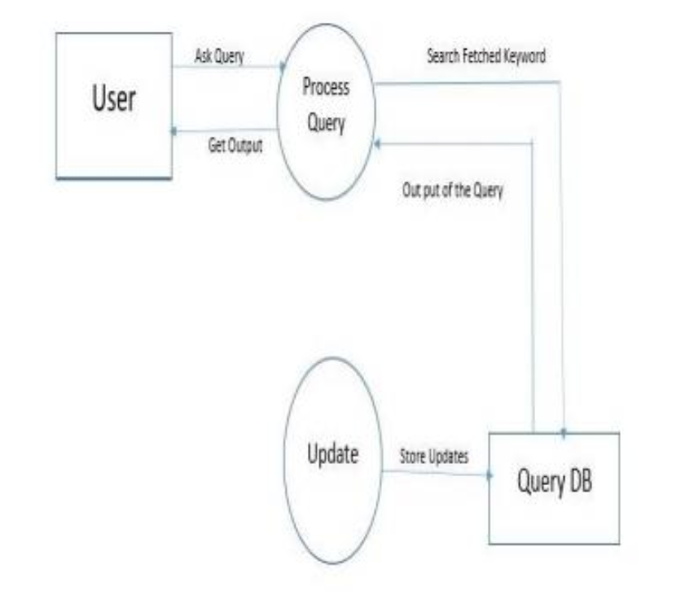

**LEVEL 2**

The next stage is to create the level 2 data flow diagram. This highlights the main functions carried out by the system. As a rule, to describe the system was using between two and seven functions - two being a simple system and seven being a complicated system. This enables us to keep the model manageable on screen or paper.

User

input

output

chatbot

train the model

**2.2ARCHITECTURAL DESIGN**

Designing a robust architecture is crucial for the success of any software system, ensuring scalability, reliability, and maintainability. Here's a breakdown of the architecture design process in six paragraphs:

**Requirement Analysis:** The first step in architecture design is to gather and analyze the requirements of the system. This involves understanding the functional and non-functional requirements, including performance, security, scalability, and integration needs. Stakeholder interviews, user stories, and use case diagrams are commonly used to capture and prioritize requirements. The goal is to establish a clear understanding of what the system needs to accomplish and how it should behave in various scenarios.

**High-Level Design:** With the requirements in hand, the next step is to create a high-level architectural design that outlines the overall structure and components of the system. This involves identifying the major modules or components, their interactions, and the technologies or frameworks to be used. Common architectural patterns such as layered architecture, microservices, or event-driven architecture may be considered based on the system's requirements and constraints. The high-level design serves as a blueprint for the detailed design and implementation phases.

**Detailed Design:** In the detailed design phase, the high-level architecture is refined into a more detailed and comprehensive design. This involves specifying the interfaces, data formats, algorithms, and protocols used by each component or module. UML diagrams such as class diagrams, sequence diagrams, and component diagrams may be created to illustrate the structure and behavior of the system. Design patterns and best practices are applied to address common design challenges and ensure the integrity and maintainability of the system.

**Scalability and Performance:** Scalability and performance considerations are critical aspects of architecture design, especially for systems expected to handle a large volume of users or data. Techniques such as horizontal scaling, vertical scaling, caching, load balancing, and asynchronous processing may be employed to ensure that the system can scale effectively and perform optimally under different load conditions. Performance testing and benchmarking are conducted to validate the design and identify potential bottlenecks or performance issues.

**Security and Reliability:** Security and reliability are paramount concerns in architecture design, particularly for systems dealing with sensitive data or critical operations. Security measures such as authentication, authorization, encryption, and data masking are implemented to protect against unauthorized access, data breaches, and other security threats. Redundancy, fault tolerance, and disaster recovery mechanisms are also incorporated to ensure high availability and resilience against failures or disruptions.

**Documentation and Review:** Throughout the architecture design process, documentation plays a crucial role in capturing and communicating the design decisions, rationale, and guidelines. Detailed design documents, architecture diagrams, interface specifications, and design guidelines are created to document the architecture and guide the implementation and maintenance activities. Additionally, design reviews and walkthroughs are conducted to solicit feedback, validate design decisions, and ensure alignment with the requirements and objectives of the system.

By following these steps and considerations, architects can design a robust and scalable architecture that meets the needs of the system and stakeholders, laying the foundation for successful implementation, deployment, and evolution.

An allocated arrangement of physical elements which provides the design solution for a consumer system architecture or systems architecture is the conceptual model that defines the structure, behaviour, and more views of a system. An architecture description is a formal description and representation of a system, organized in a way that supports reasoning about the structures and behaviours of the system.

System architecture can comprise system components, the externally visible properties of those components, the relationships (e.g. The behaviour) between them. It can provide a plan from which products can be procured, and systems developed, that will work together to implement the overall system. There have been efforts to formalize languages to describe system architecture; collectively these are called architecture description languages (adls).

various organizations define systems architecture in different ways, including:

An allocated arrangement of physical elements which provides the design solution for a consumer product or life-cycle process intended to satisfy the requirements of the functional architecture and the requirements baseline.

Architecture comprises the most important, pervasive, top-level, strategic inventions, decisions, and their associated rationales about the overall structure (i.e., essential elements and their relationships) and associated characteristics and behavior.

If documented, it may include information such as a detailed inventory of current hardware, software and networking capabilities; a description of long-range plans and priorities for future purchases, and a plan for upgrading and/or replacing dated equipment and software.

**User Input:**

The workflow begins when a user interacts with the chatbot through a messaging platform or interface. The user may ask a question, make a request, or provide information.

**Input Processing:**

The chatbot receives the user's input and processes it to understand the user's intent and extract relevant information. This process involves natural language understanding (NLU) techniques such as tokenization, entity recognition, and sentiment analysis.

**Intent Recognition:**

The chatbot identifies the user's intent or purpose behind the input. It categorizes the user's query into predefined intents, which represent the different types of actions or tasks the chatbot is designed to handle.

**Query Analysis:**

The chatbot analyzes the user's query to determine the specific information or action required. It identifies key entities or parameters mentioned in the query, such as dates, locations, products, or services.

**Response Generation:**

Based on the user's intent and query analysis, the chatbot formulates a response to provide the most relevant and helpful information or assistance. This response may be generated dynamically using predefined templates, rules, or algorithms.

**Knowledge Retrieval:**

If the user's query requires accessing external data sources or knowledge bases, the chatbot retrieves the relevant information from databases, APIs, or other sources. This could involve querying a CRM system, accessing product catalogs, or retrieving information from web sources.

**Response Delivery:**

The chatbot delivers the response to the user through the messaging platform or interface. The response may include text, images, links, or interactive elements, depending on the nature of the interaction and the capabilities of the platform.

**Feedback Collection:**

After delivering the response, the chatbot may collect feedback from the user to assess the quality of the interaction and improve its performance. This feedback could involve rating the response, providing additional context, or expressing satisfaction or dissatisfaction with the assistance received.

**Learning and Adaptation:**

Over time, the chatbot learns from user interactions and feedback to improve its performance and accuracy. It may use machine learning techniques to adapt its responses based on user behavior, preferences, and evolving language patterns.

**Monitoring and Maintenance:**

Throughout the workflow, the chatbot is monitored for performance metrics such as response time, accuracy, and user satisfaction. Regular maintenance and updates may be performed to address issues, add new features, or enhance the chatbot's capabilities based on user feedback and business requirements.

The composite of the design architectures for products and their life-cycle processes .The work progress of a chatbot typically involves several stages, including planning, development, testing, deployment, and ongoing maintenance and improvement. Here's an overview of each stage:

**CHAPTER 3**

**PROGRAM DESIGN**

**3.1 MODULES**

**Understanding Requirements**:

Program design is a critical phase in software development, involving the planning and organization of code and algorithms to achieve specific objectives effectively and efficiently. Here are six paragraphs outlining key aspects of program design:

The first step in program design is to understand the requirements and objectives of the software project. This involves gathering and analyzing user needs, business goals, and functional specifications to determine what the program should accomplish. Clear and comprehensive requirements provide the foundation for designing a solution that meets stakeholders' expectations and delivers value to end-users.

**Decomposition and Modularization:**

Program design involves breaking down the overall system into smaller, manageable components or modules. This process, known as decomposition, helps simplify the problem and enables developers to focus on designing and implementing individual parts of the system independently. Each module should have a well-defined purpose, interface, and responsibilities, facilitating modularization and reuse of code.

**Algorithm Design:**

Algorithm design is a fundamental aspect of program design, involving the development of step-by-step procedures to solve specific problems or perform tasks efficiently. Algorithms should be carefully designed to achieve the desired functionality while considering factors such as time complexity, space complexity, and scalability. Effective algorithm design requires analyzing problem constraints, identifying suitable data structures and operations, and optimizing performance where necessary.

**Data Design:**

Data design involves designing the data structures and data organization methods used within the program. This includes defining the types of data to be stored, selecting appropriate data structures (such as arrays, lists, maps, or trees), and designing relationships between different data elements. Well-designed data structures and efficient data management techniques are essential for optimizing memory usage, minimizing access times, and ensuring data integrity and consistency.

**User Interface Design:**

For programs with user interfaces, designing an intuitive and user-friendly interface is crucial for enhancing usability and user satisfaction. User interface design involves determining the layout, navigation, and visual elements of the interface to provide a seamless and engaging user experience. This may include wireframing, prototyping, and usability testing to refine the design and ensure it meets user needs and expectations.

**Testing and Validation:**

Program design should include provisions for testing and validation to ensure that the implemented solution meets the specified requirements and performs as intended. Testing may involve unit testing, integration testing, system testing, and acceptance testing to identify and address defects, errors, and inconsistencies in the software. Validation involves verifying that the software meets user needs and aligns with business goals through user feedback and validation against acceptance criteria.

Overall, effective program design requires careful planning, analysis, and consideration of various factors such as requirements, decomposition, algorithm design, data design, user interface design, and testing. By following systematic design principles and methodologies, developers can create well-structured, maintainable, and scalable software solutions that meet the needs of stakeholders and deliver value to end-users.

**Admin**

The admin module is a crucial component of many systems, particularly in organizational or management software. It serves as the control center for managing various aspects of the system's functionality, often accessible only to authorized administrators or staff with elevated privileges. Here's a brief explanation of the admin module:

User management: one primary function of the admin module is user management. Administrators can create, modify, or delete user accounts within the system. This includes assigning roles and permissions to different users, ensuring that each individual has the appropriate level of access based on their responsibilities and organizational hierarchy.

Configuration settings: the admin module typically provides access to configuration settings that govern the behavior and customization of the system. This may include setting up email templates, defining workflow processes, adjusting notification preferences, and configuring other system parameters to align with the organization's specific needs and preferences.

Data management: admins often have the ability to manage and oversee the data stored within the system. This may involve tasks such as importing/exporting data, performing backups, and implementing data retention policies. Additionally, admins may have tools for monitoring data integrity, resolving data conflicts, and ensuring compliance with relevant regulations or standards.

System monitoring and reporting: another important aspect of the admin module is system monitoring and reporting. Admins can access dashboards or reports that provide insights into system usage, performance metrics, and other key indicators. This allows administrators to track system health, identify potential issues or bottlenecks, and make informed decisions to optimize the system's effectiveness and efficiency.

In summary, the admin module serves as the central hub for managing user accounts, configuring system settings, overseeing data management tasks, and monitoring system performance. It empowers administrators with the tools and controls necessary to effectively administer and maintain the system, ensuring smooth operation and alignment with organizational objectives.

**user**

The user module is a crucial component within various software systems and applications, designed to facilitate interaction between the system and its users. It serves as an interface through which users can interact with the system, input their preferences, request information, and perform tasks. Here's an explanation of the user module in four paragraphs:

**Interface Design**: The user module encompasses the design and functionality of the user interface (UI), which is the point of interaction between the user and the system. It involves creating layouts, visual elements, and navigation paths that are intuitive and user-friendly. A well-designed user module considers factors such as user experience (UX), accessibility, and usability to ensure that users can easily navigate through the system and accomplish their tasks efficiently. Elements such as menus, buttons, forms, and multimedia components are carefully crafted within the user module to provide a seamless and engaging user experience.

**Authentication and Authorization**: Another crucial aspect of the user module is managing user authentication and authorization. This involves verifying the identity of users and granting them appropriate access rights based on their roles and permissions within the system. Authentication mechanisms such as passwords, biometrics, or multi-factor authentication are implemented within the user module to ensure the security of user accounts and protect sensitive information. Additionally, the user module handles authorization processes to determine which resources or functionalities users are allowed to access, enforcing security policies and preventing unauthorized actions.

**Personalization and Preferences**: Within the user module, provisions are made for personalization features that allow users to customize their experience according to their preferences. This may include options to set language preferences, adjust display settings, or configure notification preferences. By accommodating individual user preferences, the user module enhances user satisfaction and engagement with the system. Personalization features are often implemented using user profile management functionalities within the user module, enabling users to tailor their interactions with the system to suit their specific needs and preferences.

**Feedback and Analytics**: The user module also incorporates mechanisms for gathering user feedback and collecting analytics data to improve the system's performance and user experience over time. Feedback channels such as surveys, rating systems, and support tickets enable users to provide input on their experiences and suggest improvements. Analytics tools integrated into the user module track user interactions, behavior patterns, and usage metrics, providing valuable insights into how users engage with the system. This data can be leveraged to identify usability issues, optimize features, and refine the overall user .

**‘**

**3.2 module description**

**Query training:**

This functionality allows the administrator to input and define queries that the chatbot should be able to understand and respond to appropriately. The queries can cover a wide range of topics related to college services, such as account information, transaction history, loan inquiries, etc. The administrator can input sample queries along with their corresponding expected responses to train the chatbot effectively.

**Training model:**

In this module, the administrator can initiate the training process for the chatbot model using the provided training data. The chatbot model will undergo machine learning or natural language processing techniques to understand the patterns in the training data and improve its ability to accurately respond to user queries.

**User module:**

**Input query:**

Users can input their queries related to college services into the chatbot interface. These queries can be in natural language format, and users are encouraged to phrase their questions as they would in a conversation with a human. The chatbot should be capable of understanding and interpreting various types of user queries, ranging from simple account balance inquiries to more complex financial advice requests.

**Get result:**

Upon receiving the user's query, the chatbot processes the input using its trained model to generate an appropriate response. The chatbot retrieves relevant information from the bank's database or knowledge base and provides the user with the requested information or assistance. If the query is ambiguous or the chatbot requires additional clarification, it may prompt the user for more details to ensure accurate assistance.

.

**CHAPTER 4**

**TESTING**

**4.1 TESTING APPROCHES**

Testing an NLP (Natural Language Processing) project is a critical phase in its development cycle to ensure its accuracy, robustness, and usability. Firstly, the testing process involves analyzing the project's requirements thoroughly to understand its intended functionality and scope. This analysis guides the creation of test plans and strategies tailored to the specific objectives of the NLP project.

Secondly, various types of testing are conducted to validate different aspects of the NLP system. Unit testing involves testing individual components or modules in isolation to verify their correctness and functionality. Integration testing assesses the interactions between these components to ensure they work seamlessly together. Functional testing evaluates the system's ability to perform specific tasks such as sentiment analysis, entity recognition, or summarization accurately.

Thirdly, performance testing is essential to assess the efficiency and scalability of the NLP project under different workloads and conditions. This involves measuring response times, throughput, and resource utilization to identify potential bottlenecks or performance issues. Additionally, accuracy testing compares the system's outputs against manually annotated or ground truth data to evaluate its precision and effectiveness in understanding and processing natural language inputs.

Lastly, usability testing focuses on the user experience and interface design of the NLP project. Testers assess the system's ease of use, navigation, and accessibility to ensure it meets user expectations and provides a seamless interaction experience. By conducting these testing procedures systematically, NLP projects can be thoroughly evaluated, refined, and optimized to deliver reliable and effective natural language processing capabilities.

Top of Form

After a system has been verified, it needs to be thoroughly tested to ensure that every component of the system is performing in accordance with the specific requirements and that it is operating as it should including when the wrong functions are requested or the wrong data is introduced. Testing measures consist of developing a set of test criteria either for the entire system or for specific hardware, software and communications components. For an important and sensitive system such as an electronic voting system, a structured system testing program may be established to ensure that all aspects of the system are thoroughly tested.

Testing measures that could be followed include:

• applying functional tests to determine whether the test criteria have been met

• applying qualitative assessments to determine whether the test criteria have been met.

• conducting tests in “laboratory” conditions and conducting tests in a variety of “real life” conditions. Conducting tests over an extended period of time to ensure systems can perform consistently.

• conducting “load tests”, simulating as close as possible likely conditions while using or exceeding the amounts of data that can be expected to be handled in an actual situation.

**4.2 TYPES OF TESTING**

**UNIT TESTING**

Unit testing in an NLP (Natural Language Processing) project focuses on testing individual components or modules in isolation to ensure their functionality and correctness. In the context of NLP, unit testing involves verifying the behavior of specific functions or algorithms responsible for tasks such as tokenization, stemming, part-of-speech tagging, or sentiment analysis. Each unit test is designed to validate a particular aspect of the NLP component, checking its inputs, outputs, and internal logic against expected outcomes.

Unit testing in an NLP (Natural Language Processing) project focuses on validating individual components or modules of the system to ensure their functionality and correctness. Each component, such as tokenization, parsing, or feature extraction, is tested in isolation to verify that it performs its intended tasks accurately.

During unit testing, test cases are designed to cover various scenarios and edge cases, including typical usage patterns and potential error conditions. For example, in testing a tokenizer component, input texts with different sentence structures, punctuation marks, and special characters are provided to assess the tokenizer's ability to accurately identify and separate tokens.

Mocking and stubbing techniques are often employed to isolate the unit under test from its dependencies, such as external libraries or APIs. This allows testers to focus solely on the behavior of the component being tested without interference from external factors. For instance, when testing a feature extraction module, mock data may be generated to simulate different input scenarios without relying on real-world data sources.

Unit tests in NLP projects are typically automated to facilitate continuous integration and deployment pipelines. This automation streamlines the testing process, enabling rapid feedback on code changes and ensuring the stability and reliability of the system across iterations. Test frameworks such as pytest or unittest are commonly used to write and execute unit tests efficiently.

Overall, unit testing plays a crucial role in the development of NLP projects by identifying and rectifying defects early in the development cycle, enhancing code quality, and promoting robustness and maintainability in the system's architecture. By thoroughly testing individual components, NLP systems can achieve higher reliability and performance in processing natural language data.

**INTEGRATION TESTING**

Integration testing in an NLP (Natural Language Processing) project focuses on evaluating the interactions and interfaces between different components or modules to ensure they work together seamlessly and produce the expected outcomes. This type of testing assesses how well individual NLP components integrate with each other and with external systems or libraries, verifying the correctness of data flow, communication protocols, and error handling mechanisms.

During integration testing, NLP components are combined and tested in various configurations to validate their interoperability and compatibility. For example, integration tests may involve verifying that the tokenization module properly interfaces with the part-of-speech tagging module, ensuring that tokenized text is accurately tagged with grammatical labels. Similarly, integration tests may examine the interaction between the named entity recognition module and the sentiment analysis module to confirm that named entities are correctly identified and analyzed for sentiment.

Integration testing also includes testing the integration points between the NLP system and external dependencies such as databases, apis, or third-party libraries. This ensures that data inputs and outputs are properly handled, data integrity is maintained, and the system behaves as expected when interacting with external resources. By thoroughly testing integration points, developers can detect and resolve issues related to data exchange, format compatibility, or protocol mismatches, preventing integration failures in production environments.

Furthermore, integration testing validates error handling and exception propagation mechanisms within the NLP system. Test cases are designed to simulate various error scenarios, such as network timeouts, data inconsistencies, or resource unavailability, to verify that the system gracefully handles exceptions and maintains robustness under adverse conditions. By testing error recovery mechanisms during integration testing, developers can identify potential failure points and implement appropriate strategies to enhance system resilience and fault tolerance.

Overall, integration testing plays a crucial role in ensuring the reliability, stability, and interoperability of an NLP system by validating the integration of its components, interfaces, and external dependencies. By thoroughly testing integration points and interactions between components, developers can mitigate integration risks, identify and resolve issues early in the development lifecycle, and deliver a high-quality NLP solution that meets user expectations and requirements .**ACCEPTANCE TESTING**

This testing is done to verify the readiness of the system for the implementation. Acceptance testing begins when the system is complete. Its purpose is to provide the end user with the confidence that the system is ready for use. It involves planning and execution of functional tests, performance tests and stress tests in order to demonstrate that the implemented system satisfies its requirements.

**VALIDATION TESTING**

Valid and invalid data should be created and the program should be made to process this data to catch errors. When the user of each module wants to enter into the page by the login page using the use rid and password .if the user gives the wrong password or use rid then the information is provided to the user like “you must enter user id and password”. Here the inputs given by the user are validated. That is password validation, format of date are correct, textbox validation. Changes that need to be done after result of this testing.

Validation testing in the context of NLP (Natural Language Processing) projects focuses on assessing the overall accuracy, effectiveness, and suitability of the system for its intended purpose. It involves evaluating the system's performance against predefined criteria and real-world data to validate its capabilities and ensure it meets user expectations.

During validation testing, the NLP system is tested with a diverse range of inputs representative of the target domain or application. This includes different languages, dialects, writing styles, and subject matters to assess the system's ability to handle various linguistic nuances and contexts accurately. For example, a sentiment analysis system may be tested with a mix of positive, negative, and neutral texts across different topics to validate its classification accuracy.

Validation testing often involves comparing the system's outputs against manually annotated or ground truth data to measure its accuracy and reliability. This may include using metrics such as precision, recall, F1-score, or confusion matrices to quantify the system's performance across different tasks such as text classification, named entity recognition, or machine translation.

In addition to quantitative metrics, qualitative assessment is also essential during validation testing to evaluate the system's overall usability and effectiveness from a user's perspective. This may involve soliciting feedback from end-users, domain experts, or stakeholders to identify any usability issues, ambiguities, or areas for improvement in the system's functionality or user interface.

Validation testing is an iterative process that continues throughout the development lifecycle of an NLP project, with testing activities becoming increasingly rigorous as the system matures. It helps validate the system's correctness, robustness, and generalization capabilities across diverse datasets and usage scenarios, ultimately ensuring that the NLP system delivers accurate, reliable, and actionable insights for its intended users.

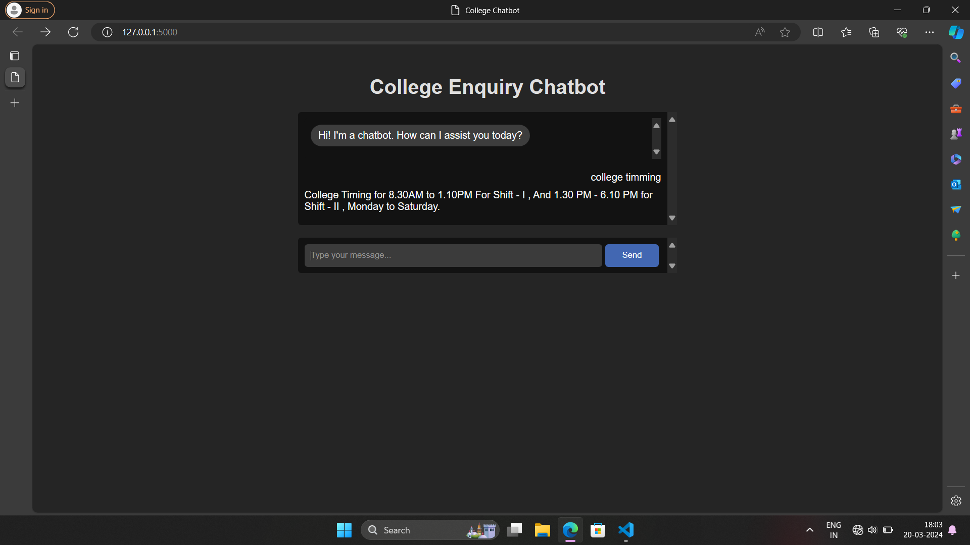

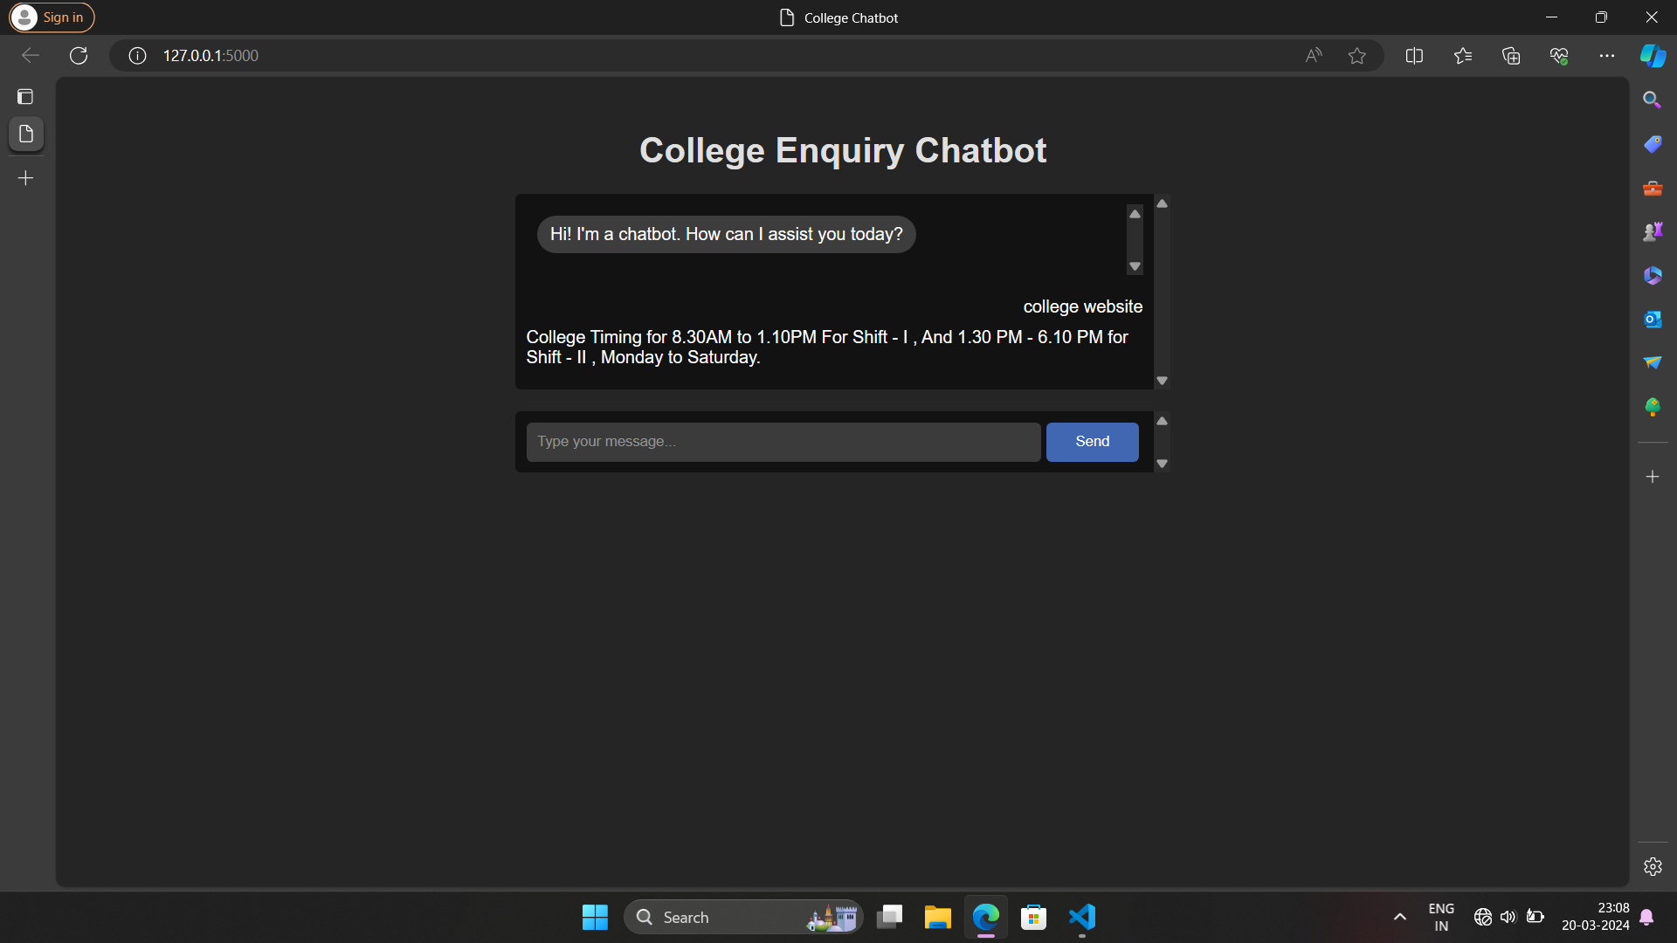

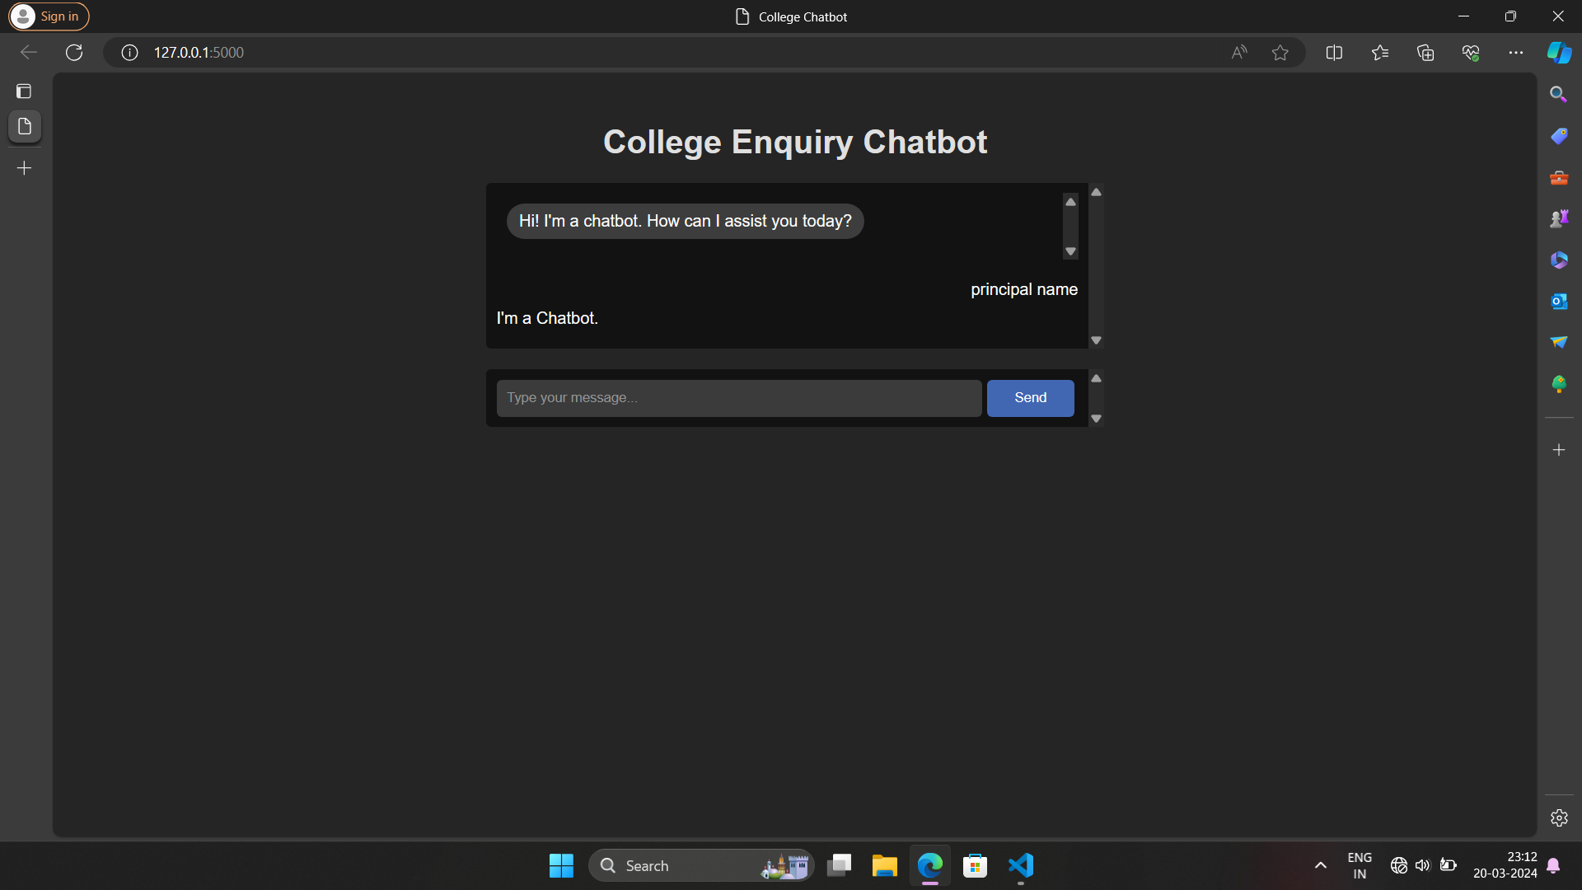

**CHAPTER 5**

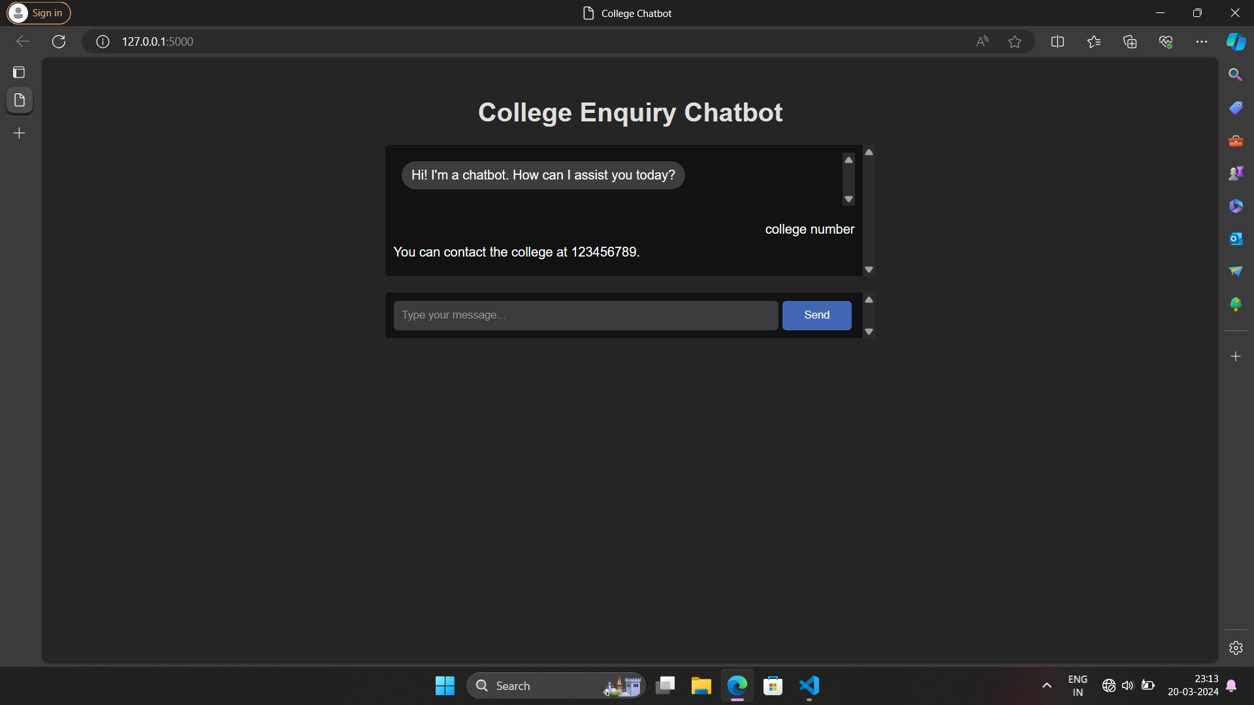

**CONCLUSION**

In conclusion, the development and implementation of the college chatbot represent a significant milestone in enhancing the quality of services and support within the college ecosystem. Through its round-the-clock availability, intuitive interface, and personalized assistance, the chatbot addresses the limitations of the existing system and revolutionizes the way students, faculty, and staff interact with college resources.

The college chatbot offers numerous benefits, including improved accessibility, enhanced user experience, increased efficiency, and data-driven insights. By providing 24/7 access to information and support services, the chatbot empowers users to overcome time constraints and access the assistance they need at their convenience. Its natural language understanding capabilities and integration with college systems enable seamless interactions and efficient task completion.

Through our exploration of the college enquiry chatbot's functionalities, we have seen how it can provide timely and accurate responses to a wide range of queries, reducing the burden on college staff and improving the overall user experience for prospective students. With its ability to handle inquiries 24/7, the chatbot ensures accessibility and responsiveness, catering to the diverse needs and schedules of students around the globe.

Moreover, the implementation of a college enquiry chatbot contributes to operational efficiency and cost-effectiveness for educational institutions. By automating routine inquiries and administrative tasks, the chatbot frees up valuable staff resources, allowing them to focus on more complex and personalized interactions with students. Additionally, the chatbot serves as a valuable data collection tool, providing insights into frequently asked questions, user preferences, and areas for improvement in the admissions process.

Looking ahead, the college enquiry chatbot represents just the beginning of the potential applications of nlp technology in higher education. As the field continues to evolve, there are opportunities to further enhance the chatbot's capabilities, such as incorporating machine learning algorithms to improve response accuracy and personalization.g innovation .

**CHAPTER 6**

**REFERANCE**

**Book Reference**

* Van Rossum, Guido, and Fred L. Drake. The python language reference manual. Network Theory Ltd., 2011.
* Van Rossum, Guido, and Fred L. Drake. The python language reference manual. Network Theory Ltd., 2011.
* Dierbach, Charles. Introduction to Computer Science using Python: A Computational Problem-Solving Focus. Wiley Publishing, 2012.
* James, Mike. Programmer's Python: Everything is an Object Something Completely Different. I/O Press, 2018.
* Reges, Stuart, Marty Stepp, and Allison Obourn. Building Python Programs. Pearson, 2018.

**Web References**

* <https://thecleverprogrammer.com/2023/03/27/end-to-end-chatbot-using-python/>
* <https://www.learnpython.org/>
* <https://docs.python.org/3/tutorial/>
* https://www.geeksforgeeks.org/python-programming-language/

**\**